We Must #Unthink Healthcare   
My #PinkSocks Story

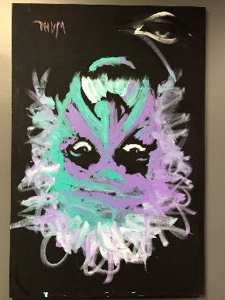

I’ve worked in healthcare IT and related fields since the early 1990s. In 2000 I joined a then-startup EMR company. You may have heard of it - Greenway Health. As an attorney, digitizing health records seemed like a great idea, so I signed on as VP, Secretary, General Counsel & Chief Privacy Officer at Greenway.

There were so many rules and regulations happening during this time. HIPAA compliance, patient access to medical records, new payment models, usable design, and the puzzle of interoperability.

My experience with healthcare has a personal side as well. I managed to keep my local orthopedic clinic busy with fractured hand, foot, knee, and most recently a wrist that now boasts a titanium screw. In addition to that, my wife Debbie has Type 1 Juvenile Diabetes. With the help of multiple doctors, numerous specialist visits, and countless sonograms, we were blessed with three healthy, beautiful children, all carried to full term.

When Greenway Health was acquired, I started my own firm, Esslinger Tech Law, to help start-up and small technology businesses succeed. Not long after that, I reconnected with a friend at Fogo Data Centers, and Fogo quickly became a full-time natural fit for me. I joined as CEO, focusing the company on applied expertise in healthcare data management and compliance.

The questions around data management and security can be dizzying. How is data being collected? How is it being stored? Discarded? How secure is your cloud-based data strategy? With each delivery model: Infrastructure as a Service (IaaS), Platform as a Service (PaaS) and Software as a Service (SaaS), comes a new set of requirements and responsibilities. Keeping a clear head can be a challenge.

To keep things simple, and stay in touch with my creative side, I have the above art piece in my office, hanging upside down as it was when the artist painted it. A reminder that things are not always as they seem, and a new perspective can be astounding. I purchased the art at auction benefitting the [Rapha Clinic of West Georgia](http://www.raphaclinic.org/), a faith-based charitable clinic providing free medical and low cost dental services to the underinsured of west Georgia and east Alabama. The portrait of Einstein was performed by artist Eric Wahl, author of [“Unthink: Rediscover Your Creative Genius”](https://www.amazon.com/Unthink-Rediscover-Your-Creative-Genius/dp/0770434002/ref=sr_1_1?ie=UTF8&qid=1483461219&sr=8-1&keywords=unthink), a book about using creativity to achieve better performance.

My journey as a healthcare CEO and General Counsel is a personal one. There’s a lot of peace and love but there’s also a deep desire to #GSD. I began in EMR in 2000. In 2017, I understand the importance to “unthink” healthcare. From payment models, to patient access, to data security, we must get back to basics and begin with honest intention. Put people first, create a culture and provide services that invest in bridging the human gap. Only then can we transform healthcare.

-Bill

William G. Esslinger, Jr. – CEO Fogo Data Centers #KnowYourCloud #pinksocks

<http://fogodatacenters.com>